**Factors of Growth and Innovation in Emerging Markets - Case study: India**

**Overview**

In this post, we seek to examine what are the factors that drive growth and innovation in an emerging market economy such as that of India’s. By focusing on the number of patents registered as an indicator of Indian innovation over the past few decades, we can speculate as to what may be driving this growth. Certainly, post-liberalization growth in the 1990s era of Manmohan Singh, and Narsimha Rao, played no small part. However, while factors such as GDP responded more quickly, business innovation and risk taking was slower to respond to market liberalization.

**Introduction**

What drives innovation? For anyone studying economics, one of the earliest introductions to comparative developments of societies comes in the form of the demographic transition model. This theory outlines trajectories in life spans, birth rates, and other vital demographic indicators of a population.

Since there is no equivalent theory for economic growth, except that market liberalization and democratization seems to be favorable to higher growth rates, we examine drivers of growth internal to a country. One model of economic growth comparable to the demographic transition model, however, is the allocation of the workforce to various sectors of the economy. Historically, we have seen service economies perform better relative to manufacturing or agriculturally based economies.

Moreover, the distribution of the workforce across the three sectors, and their relative contribution to the gross domestic product is a telling sign of economic growth. Historically, a shift away from agriculture and industrial production, towards service sector jobs, is a good indicator of healthy economic growth. And this is what we see in India. In order to drill down further to decipher whether this growth is coming from within the country’s economy rather than simply from outsourced jobs from advanced economies, we examine business formation and patent registration metrics, and find a stark increase.

**Insights**

Data for this project comes primarily from the World Bank’s World Development Indicators data - an excellent repository of information compiled from sources such as the IMF’s balance of payments data.

Exploratory Trends:

In the figure below, figure 1, we see a marked increase in the overall Indian GDP. Specifically, post liberalization, GDP growth increases exponentially.

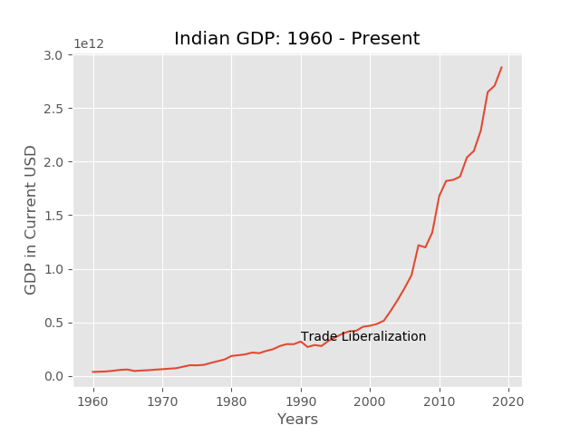

Figure : Indian GDP: 1960 – Present

This aggregate figure alone is only part of the story. A decomposition by sector shows that service sector growth is largely responsible for this increase.

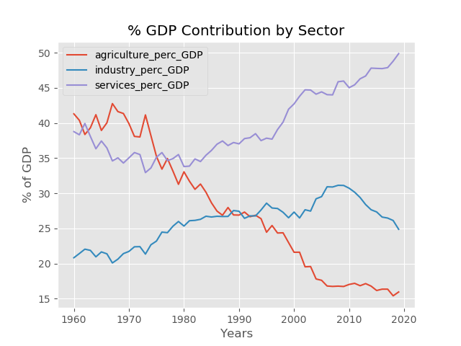

Figure : % GDP by Sector

A look at Foreign Direct Investment, or net capital inflows, tells a similar story about what could be spurring service sector growth.

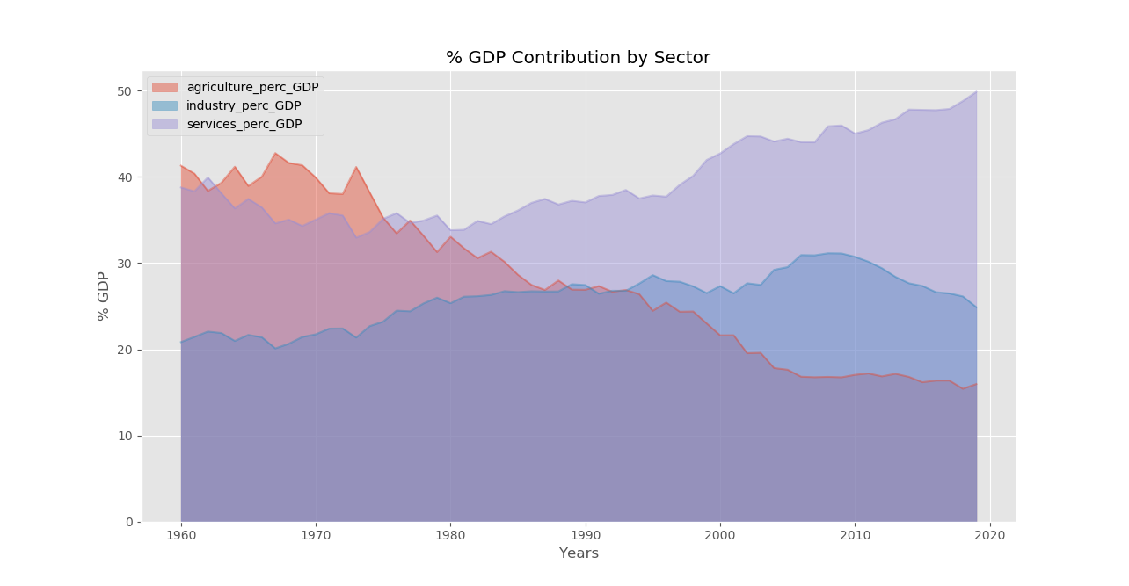

Figure : % GDP by Sector

Finally, in the figure above, we see the relative growth of the service sector industry’s contribution to GDP, with a decline in the contribution of the manufacturing and production sector since the past decade, and a relative leveling off of the agricultural sector for the past decade.

This divergence in the contributions by sector is further seen in the diagram below, where we see a shift in the workforce away from agriculture and towards manufacturing and service sector jobs. Given that manufacturing jobs are low margin jobs, it’s no wonder that their contribution is still low relative to service sector jobs.

However, the growth in service sector jobs, and the relative contribution to economic growth is one of the more tell-tale signs of a growing economy, and of industrialized agricultural production. A shift away from labor intensive agriculture to capital intensive agriculture is likewise the reason so many smaller scale farmers in recent years saw a declining share of the market, while larger scale farmers were able to withstand market fluctuations and volatility. 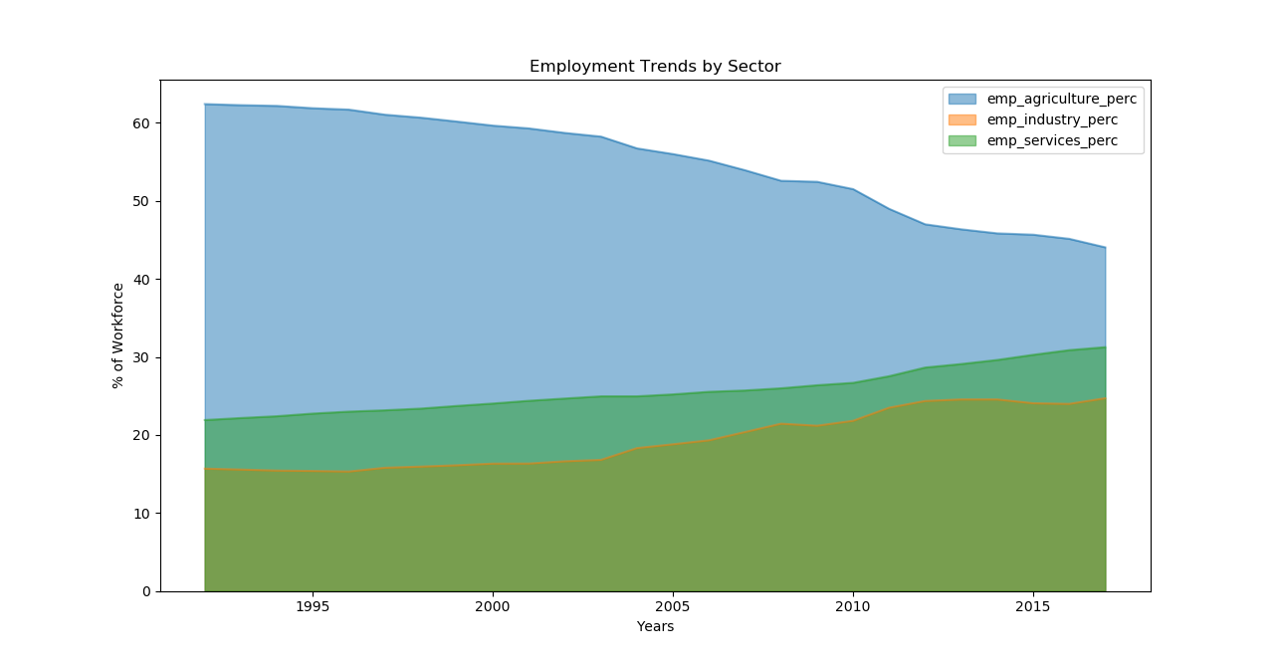

Figure : % Workforce by Sector

Key Insights:

Below is the real crux of the data. 1990 was the year agriculture’s contribution to the gdp dipped below the amount contributed by the manufacturing sector. It is difficult to say whether these manufacturing jobs were generated by local captains of industry and barons. Or if the newfound growth in manufacturing and service sector jobs was simply a result of foreign companies offshoring their production.

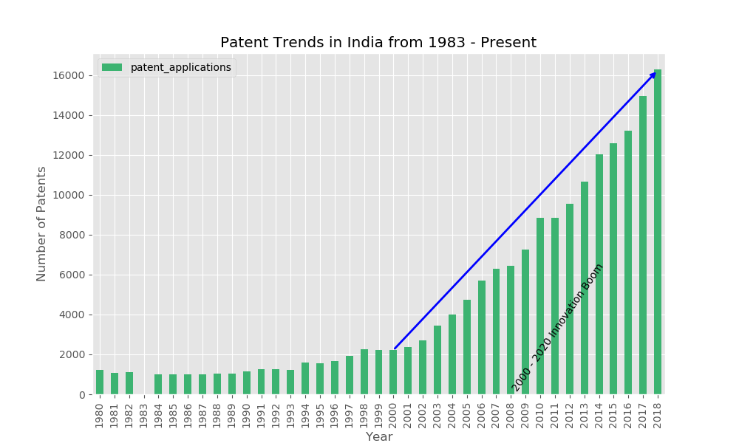

Figure : patents registered from the 1980s onward

In the figure above therefore, we see a relative plateau of the number of patents registered by Indian residents during the 1990s. Somewhere towards the end of the 1990s, whether owing to the ‘dot com’ boom, and a global multiplier effect, or to India’s own flourishing of entrepreneurship, there is a steep increase in the number of patents registered. And, given that it requires some technical savvy just to register a patent, we can therefore infer that innovativeness was on the increase.

Lastly, we identify and examine two other metrics. The controversial ease of doing business index, of recent times. And the rate of business formation itself.

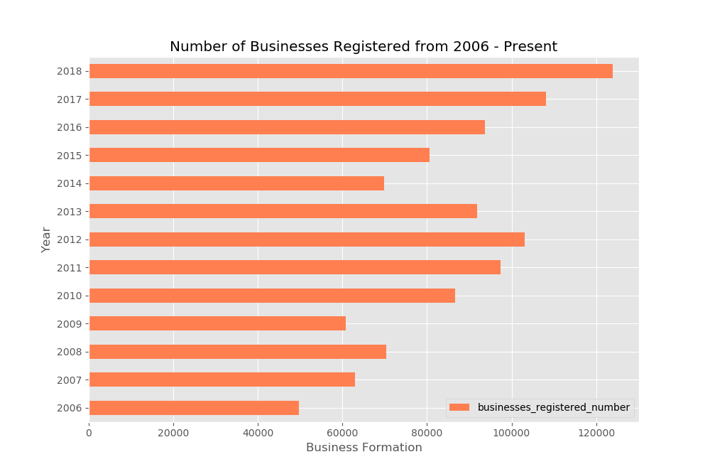

Figure : number of businesses registered

The number of businesses registered, another metric that is calculated based on Indian residents, also points to the fact that growth is internal. That there are new entrants into the market, makes Indian firms price setters rather than price takers. The above graph displayed, while a bit more volatile and cyclical in nature nonetheless shows a growth in businesses registered, and indicates increased risk taking.

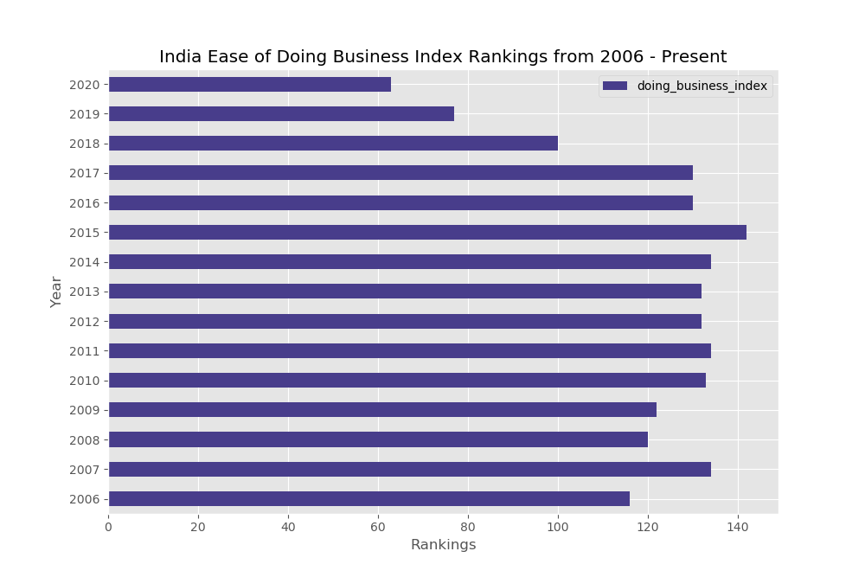

Figure : ease of doing business index

Finally, the ease of doing business index, shows India has made a significant jump in rankings in recent years – particularly since 2017. All these metrics combined point to an openness on Indian ground to doing business, and to doing it well. Outposts of international firms meant for cost-cutting, and organic growth of Indian firms alike point to significant growth trends on Indian soil in the years to come.

Our results show that post economic liberalization in India there was

1. A steep incline the GDP increase from 1990 onwards
2. A steady stream of innovation from the early 2000s up until the present
3. A sharp incline in the numbers of business formation for the past 5 years, from 2015 up until the present
4. An amenable change in the ease of doing business, and a jump in the rankings from 2015 up until the present

**Conclusion**

Ascribing these changes to Modi’s conservative consolidated government alone may be a bit presumptuous. But he has presided over some of these changes. At the same time, he has been known to turn a blind eye to civil strife, and not taking responsibility is all too convenient.

India is at a crossroads, where conformity is valued over diversity. This is an age-old tale of assimilation versus inclusion. And at the heart of this issue are the minority groups subject to the majority group’s agenda–setting. But the numbers indicate that business is growing. One would hope that a more inclusive dialogue is part of the economic agenda, and that abuses of power are outright condemned.

**Work Cited**

[1] Schumacher, E. F. (1973). Small is beautiful: Economics as if people mattered. New York: Harper & Row.

[2] Bell, Alex, et al. "Who becomes an inventor in America? The importance of exposure to innovation." The Quarterly Journal of Economics 134.2 (2019): 647-713.